VINE HOUSE SURGERY NEWSLETTER
AUGUST 2020

OUR CLINICAL TEAM
Dr Baker (2 days a week)
Dr Mucherla (4 days a week)
Dr Jurgita (5 days a week)
Sasha McIntosh – Nurse Practitioner (4 days a week) Claire Nicholls – Nurse Practitioner (4 days a week)
Elizabeth Reader – Care Co-Ordinator (5 days a week)

THE CORONAVIRUS

If you have symptoms of coronavirus (a high temperature, a new or continuous cough or a rash) do not go to places like a GP surgery, pharmacy, or hospital. If you have these symptoms, use the 111 or 119 Coronavirus service to find out what to do.

Everyone is being reminded to follow Public Health England advice to:
- Always carry tissues with you and use them to catch your cough or sneeze. Then bin the tissue, and wash your hands, or use a sanitiser gel.
- Wash your hands often with soap and water, especially after using public transport. Use a sanitiser gel if soap and water are not available.
- Avoid touching your eyes, nose and mouth with unwashed hands.
- Avoid close contact with people who are unwell.
You can find the latest information and advice from Public Health England.

FACIAL MASKS/ Coverings
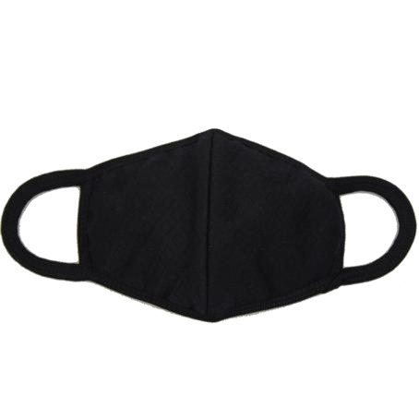

We would firstly like to thank all patients who have visited the Practice over the last few weeks wearing a face covering.

We know that this can feel strange and uncomfortable, make glasses fog up and make communicating with others harder but by doing this you are protecting the most vulnerable members of our community, so thank you, it really is appreciated.
We have had an increase in requests from patients for letters of exemption to wearing face masks in various public settings over the last few days.
In England, you must by law wear a face covering on public transport now, and in shops and supermarkets as of 24th July 2020.
The Government guidance suggests there is no requirement for evidence for exemption. It should be sufficient for someone to declare that they are eligible for an exemption directly with the person questioning them (e.g. bus driver).
Whilst we would urge you to wear a face covering if you possibly can to protect those around you we do know that for some people this raises particular extreme challenges.
There is no exemption certificate and we as a practice are unable to provide letters of support for those who fall under the list of exemptions, or to those who do not fall under the list of exemptions however the attached card can be printed and used to help explain why you aren’t wearing a face covering if you are unable to do so. B19-Mask-ExemptionCards

ASKM
YGP

We are now using askmyGP system to allow patients to message their Doctor directly. Rather than having to wait for an appointment this system means that your message should be dealt with that day (if you message on weekdays until 4pm). This service is available for all Doctor and Nurse Practitioner appointments. If you need to see a Practice Nurse or Health Care Assistant e.g. for a long-term condition review, injection, blood test or a smear test please telephone the surgery.
Our new service, askmyGP, now means that you can request help from the practice when, where and how it suits you. Enjoy feeling more in control as you ask for help securely from your smartphone, tablet or computer. Bookmark the link in your browser so you don’t forget. If you don’t have internet access you can contact the practice by telephone and your request will be sent to the clinician who will contact you that day where you will manage by telephone or invited in that day to see the clinician.
What is askmyGP?
It’s our online service where you can seek help from a clinician. The information you give us means the clinicians are better informed and can help you with your problem quicker.
~ You can message us at any time.
~ There’s no need to book ahead.
~ You can ask for an individual clinician and check when they are working.
~ You can look forward to prompt response in working hours.
~ You can let us know and when it’s best to get back to you.
Please follow this link on our website www.vinemedical.com and click on the askmyGP tab

PHYSIOTHERAPY
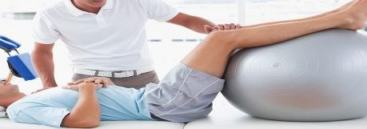

Phil Richards has joined us and works on a Monday and Thursday. He can deal with all musculoskeletal problems. Patients can request appointments or telephone consultations
with him via AskmyGP which can be accessed through our website www.vinemedical.com

EXTENDED HOURS

Evenings & Weekends
We are pleased to be able to offer our patients access to routine, pre-booked appointments at evenings and weekends. The new service is part of an extended access service which has been commissioned by NHS South West Lincolnshire Clinical Commissioning Group. Extended hours run between 18:30 and 20:00 weekdays and 09:00 and 12:00 Saturday and Sunday and are available on bank holidays and across the Easter, Christmas and New Year periods.
Appointments are for pre-bookable, non-urgent consultations with GPs and Nurses.
Examples of these include chronic illness, asthma checks and routine GP appointments.
The service is being delivered at Sleaford Medical Group and managed by a federation of GPs in the Sleaford area. This means that your appointment could be with a health professional from any of the federation practices.
To arrange an appointment, please speak to your practice receptionist.
When booking an appointment you will need to consent to a Consulting Clinician that may not be your own GP viewing and updating your health record.
Important things to remember
- These are pre-bookable and not urgent, acute ‘on the day’ matters
- Booked in advance through your own GP reception
- May be with a health professional from any of the federation practices
- At St Peters Hill Surgery, 15 St Peters Hill, Grantham, NG31 6QA
- Extended Access hours are between 18:30 and 20:00 weekdays and 09:00 and 12:00 Saturday and Sunday
- These appointments are additional capacity across the federation practices If you would like more information please ask at reception

MEDICATION REVIEWS
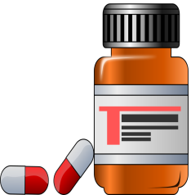

Nisha Ladva and Ayaz Hussain our Clinical Pharmacists are working within the clinical team helping with medicines management. Clinical Pharmacists bring a range of new skills to
General practice. As specialist in medicines they can support GPs and other members of the Practice team. Nisha will be involved in the medication reviews of long-term conditions, such as
Asthma
Chronic Obstructive Pulmonary Disease
Diabetes
Cardiovascular Disease
Hypertension

They will have appointments available for these reviews to be done, please make an appointment at reception if you are due a medication review.

DENTISTS

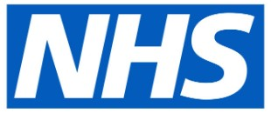
Access to NHS Dentistry is currently limited during the pandemic as all dentists have been asked to stop
all routine “face-to-face” dental care.
However, if you need urgent dental care, help is at hand:
CALL your dental practice:
They will give you advice over the telephone and make arrangements for you if you need to be seen.

If you don’t have a dentist, find your nearest dentist and CALL them. You can search for your nearest dentist at: https://www.nhs.uk/service-search/find-a-dentist

You can also contact NHS 111:
You can ask for a translator if you need one.
NHS 111 is available 24 hours a day, 7 days a week

If you’re deaf, you can:
- use the NHS 111 British Sign Language service: interpreternow.co.uk/nhs111 or
- call 18001 111 on a textphone

Do not worry if you have COVID-19 symptoms, appropriate arrangements can be made to see you if you need urgent dental care.

SAFETY ALERTS

There have been several alerts reported in the news recently. These alerts are dealt with by our Medicines Management and Dispensary teams who work hard to ensure that these are actioned in a safe and timely manner.
There are different types of alert:
- Stock shortage alert – these are issued when there are national or global shortages of a medication. In these cases, we will contact you once supplies are no longer available and arrange a suitable alternative.
- Drug alerts – these are issued when a manufacturer identifies a fault with one of their products. This can be related to the medicine itself or its packaging. There are different levels of drug alert and often they do not require us to contact individuals. However, on the rare occasion that this does happen we have a robust system in place to contact patients.

FRIENDS AND FAMILY
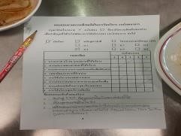
We strive to constantly improve our service. We would be grateful if you could complete a questionnaire available in reception or via AskmyGP. Your opinion matters.

NHS 111
Think you need medical help right now? NHS 111 is available online, as well as over the phone! NHS 111 is much more than a helpline – if you’re worried about an urgent medical concern, call 111or visit 111.nhs.uk

PATIENT PARTICIPATION GROUP (PPG)

The aim of a PPG is to represent patient’s views, support diversity and to work in partnership with the Practice to improve common understanding; help patients to take
more responsibility for their health; contribute to improvements of service and quality of care and work towards better and improved communications. Our next meeting has not been arranged due to the Covid19 pandemic.

Minutes from our previous PPG meetings can be viewed on our practice website www.vinemedical.com

CARE QUALITY COMMISSION (CQC)
We are delighted to report that following our Care Quality Commission inspection in June 2016 the practice has been awarded a “GOOD” rating. The full report can be seen on the website below.

WWW.CQC.ORG.UK

